Structure for Users table:

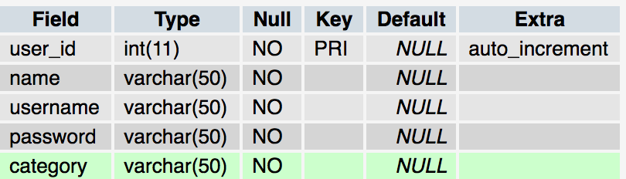

Structure for Items table:

